Visual Recognition in Traffic for safety ride Using Helmet

Model ID : DefaultCustomModel_1984687990

import json

from watson_developer_cloud import VisualRecognitionV3

visual_recognition = VisualRecognitionV3(

'2018-03-19',

iam_apikey='{iam_api_key}')

with open('./h6.jpg', 'rb') as images_file:

classes = visual_recognition.classify(

images_file,

threshold='0.6',

classifier_ids='default').get_result()

print(json.dumps(classes, indent=2))

Example:

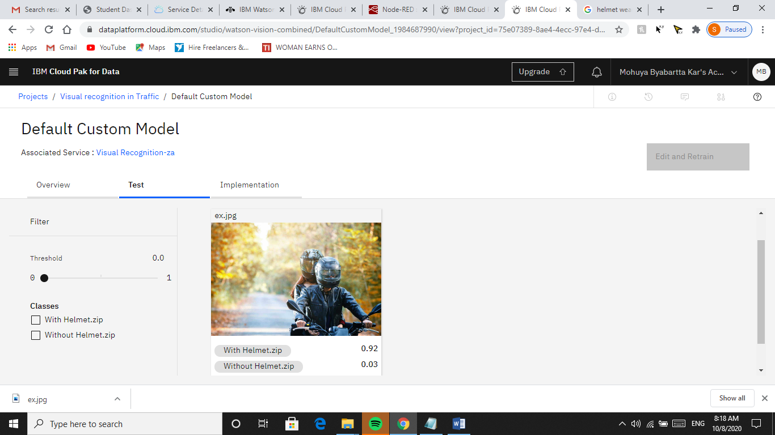

Track Work Place Condition to Ensure Safety

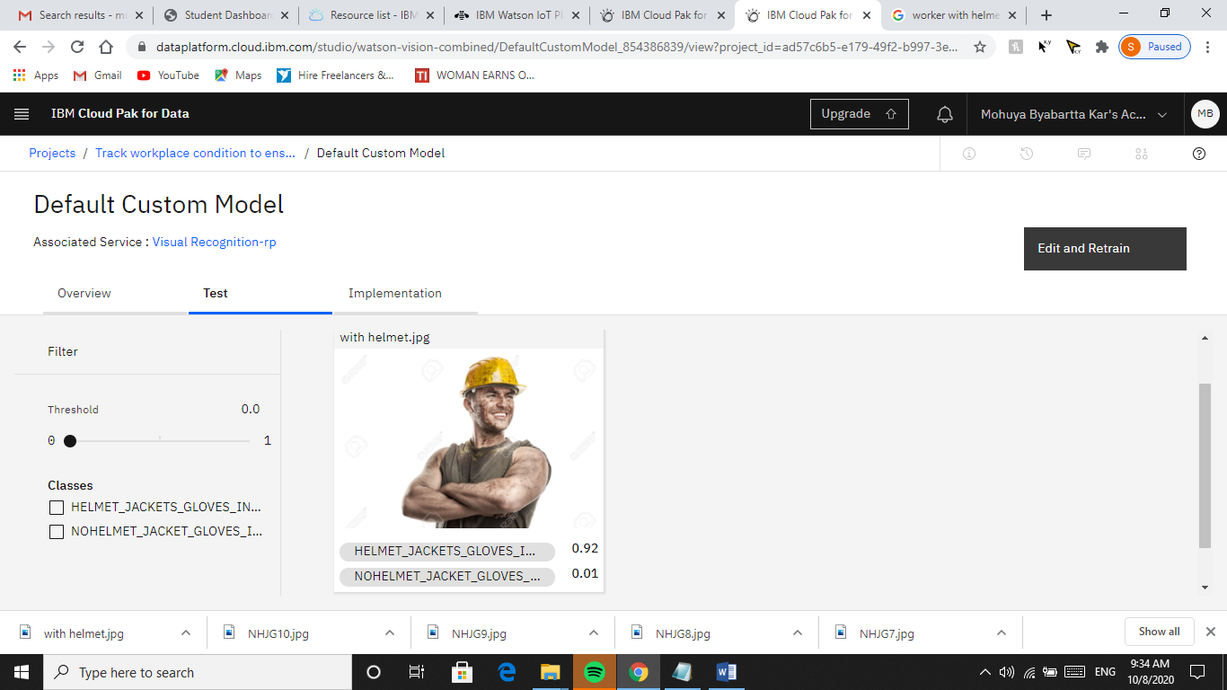

Helmet||Jacket ||Gloves=.92 ensures Safety in workspace

Services Required :Visual Recognition

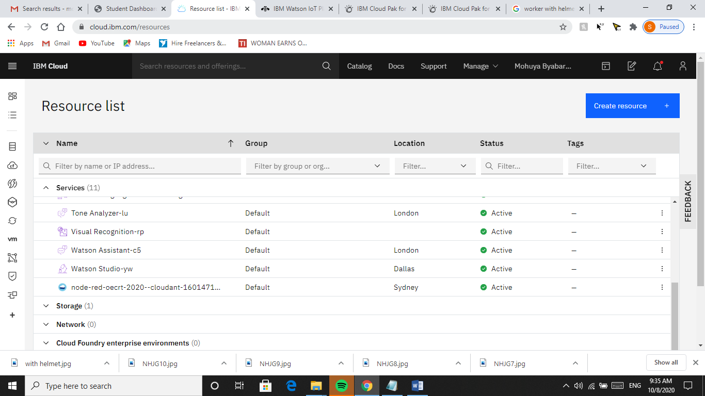

Datasets :

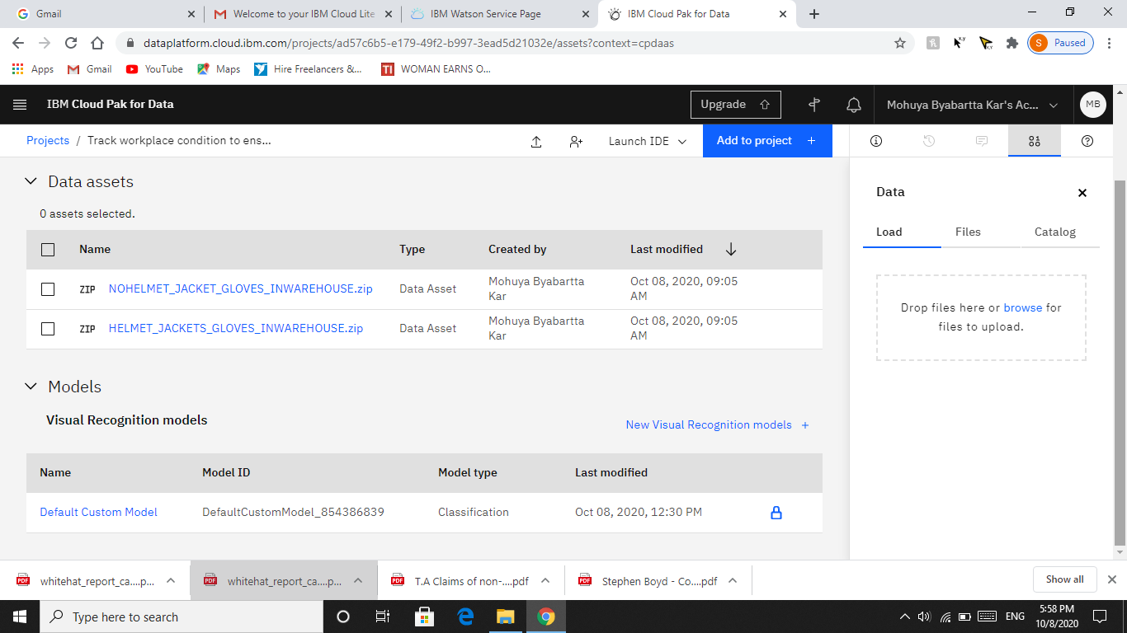

The Active Events going around while you are working on IBM Cloud

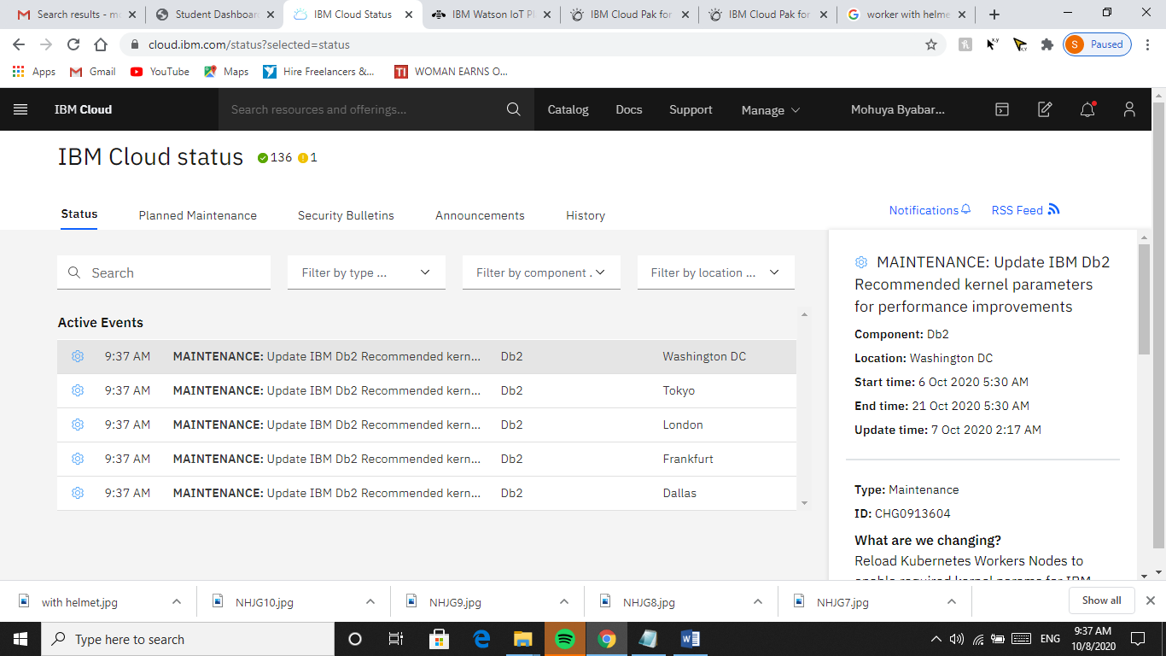

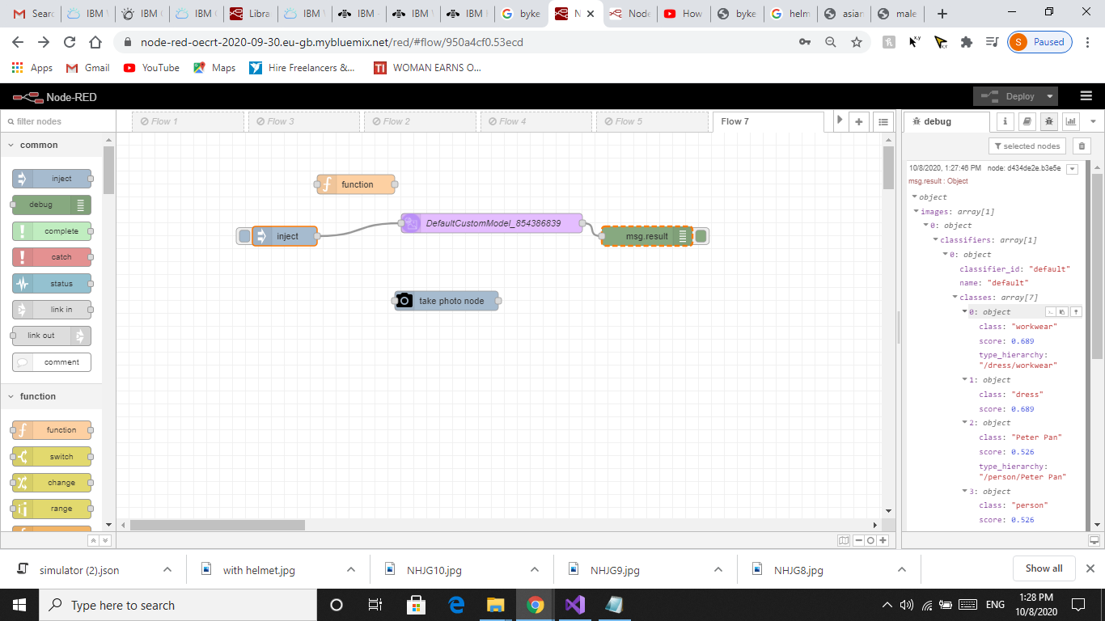

Node Red flows defined for the procedure, and the Class and Score obtained against each object in the Image. Score above .50 ensures positivity where as if score is less than .50, the object left is unrecognized.



